# What is PCA?

* Principal Component Analysis, or PCA, is a dimensionality-reduction method that is often used to reduce the dimensionality of large data sets, by transforming a large set of variables into a smaller one that still contains most of the information in the large set.
* Reducing the number of variables of a data set naturally comes at the expense of accuracy, but the trick in dimensionality reduction is to trade a little accuracy for simplicity. Because smaller data sets are easier to explore and visualize and make analyzing data much easier and faster for machine learning algorithms without extraneous variables to process.

-> So to sum up, the idea of PCA is simple — reduce the number of variables of a data set, while preserving as much information as possible.

# Why use PCA in the first place?

To support the cause of using PCA let’s look at one example. Suppose we have a dataset having two variables and 10 number of data points.

If we were asked to visualize the data points, we can do it very easily. The result is very interpretable as well.

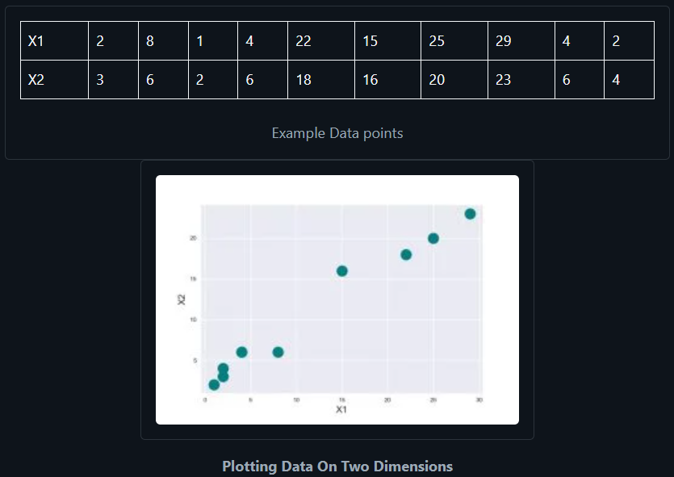

Now if we try to increase the number of variables it gets almost impossible for us to imagine a dimension higher than three-dimensions.

This problem we face when analyzing higher-dimensional datasets is what commonly referred to as “The curse of dimensionality”. This term was first coined by Richard E. Bellman.

-> Principal Component Analysis reduces high dimensional data to lower dimensions while capturing maximum variability of the dataset.

Data visualization is the most common application of PCA. PCA is also used to make the training of an algorithm faster by reducing the number of dimensions of the data.

We can think of Principal Component analysis to be like fitting an n-dimensional ellipsoid to the data so that each axis of the ellipsoid represents a principal component. The larger the principal component axis the larger the variability in data it represents.

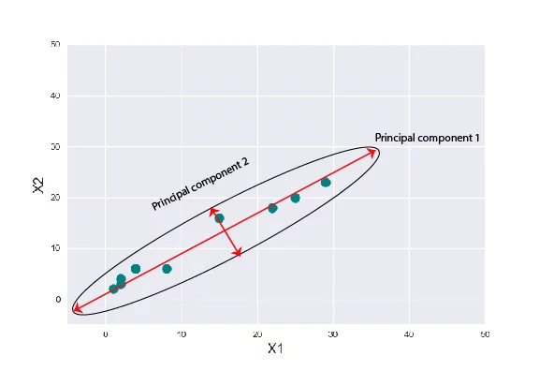

# Explanation of PCA

## 3.1. STANDARDIZATION

The aim of this step is to standardize the range of the continuous initial variables so that each one of them contributes equally to the analysis.

More specifically, the reason why it is critical to perform standardization prior to PCA, is that the latter is quite sensitive regarding the variances of the initial variables. That is, if there are large differences between the ranges of initial variables, those variables with larger ranges will dominate over those with small ranges (For example, a variable that ranges between 0 and 100 will dominate over a variable that ranges between 0 and 1), which will lead to biased results. So, transforming the data to comparable scales can prevent this problem.

Mathematically, this can be done by subtracting the mean and dividing by the standard deviation for each value of each variable. Once the standardization is done, all the variables will be transformed to the same scale.

## 3.2. COVARIANCE MATRIX COMPUTATION

The aim of this step is to understand how the variables of the input data set are varying from the mean with respect to each other, or in other words, to see if there is any relationship between them. Because sometimes, variables are highly correlated in such a way that they contain redundant information. So, in order to identify these correlations, we compute the covariance matrix.

The covariance matrix is a p × p symmetric matrix (where p is the number of dimensions) that has as entries the covariances associated with all possible pairs of the initial variables. For example, for a 3-dimensional data set with 3 variables x, y, and z, the covariance matrix is a 3×3 matrix of this from:

Since the covariance of a variable with itself is its variance (Cov(a,a)=Var(a)), in the main diagonal (Top left to bottom right) we actually have the variances of each initial variable. And since the covariance is commutative (Cov(a,b)=Cov(b,a)), the entries of the covariance matrix are symmetric with respect to the main diagonal, which means that the upper and the lower triangular portions are equal.

What do the covariances that we have as entries of the matrix tell us about the correlations between the variables?

It’s actually the sign of the covariance that matters :

* if positive then: the two variables increase or decrease together (correlated)
* if negative then : One increases when the other decreases (Inversely correlated)

Now that we know that the covariance matrix is not more than a table that summarizes the correlations between all the possible pairs of variables, let’s move to the next step.

## 3.3. COMPUTE THE EIGENVECTORS AND EIGENVALUES OF THE COVARIANCE MATRIX TO IDENTIFY THE PRINCIPAL COMPONENTS

Eigenvectors and eigenvalues are the linear algebra concepts that we need to compute from the covariance matrix in order to determine the principal components of the data. Before getting to the explanation of these concepts, let’s first understand what do we mean by principal components.

Principal components are new variables that are constructed as linear combinations or mixtures of the initial variables. These combinations are done in such a way that the new variables (i.e., principal components) are uncorrelated and most of the information within the initial variables is squeezed or compressed into the first components. So, the idea is 10-dimensional data gives you 10 principal components, but PCA tries to put maximum possible information in the first component, then maximum remaining information in the second and so on, until having something like shown in the scree plot below.

Organizing information in principal components this way, will allow you to reduce dimensionality without losing much information, and this by discarding the components with low information and considering the remaining components as your new variables.

An important thing to realize here is that the principal components are less interpretable and don’t have any real meaning since they are constructed as linear combinations of the initial variables.

Geometrically speaking, principal components represent the directions of the data that explain a maximal amount of variance, that is to say, the lines that capture most information of the data. The relationship between variance and information here, is that, the larger the variance carried by a line, the larger the dispersion of the data points along it, and the larger the dispersion along a line, the more the information it has. To put all this simply, just think of principal components as new axes that provide the best angle to see and evaluate the data, so that the differences between the observations are better visible.

### **HOW PCA CONSTRUCTS THE PRINCIPAL COMPONENTS?**

As there are as many principal components as there are variables in the data, principal components are constructed in such a manner that the first principal component accounts for the largest possible variance in the data set. For example, let’s assume that the scatter plot of our data set is as shown below, can we guess the first principal component ? Yes, it’s approximately the line that matches the purple marks because it goes through the origin and it’s the line in which the projection of the points (red dots) is the most spread out. Or mathematically speaking, it’s the line that maximizes the variance (the average of the squared distances from the projected points (red dots) to the origin).

The second principal component is calculated in the same way, with the condition that it is uncorrelated with (i.e., perpendicular to) the first principal component and that it accounts for the next highest variance.

This continues until a total of p principal components have been calculated, equal to the original number of variables.

Now that we understood what we mean by principal components, let’s go back to eigenvectors and eigenvalues. What you firstly need to know about them is that they always come in pairs, so that every eigenvector has an eigenvalue. And their number is equal to the number of dimensions of the data. For example, for a 3-dimensional data set, there are 3 variables, therefore there are 3 eigenvectors with 3 corresponding eigenvalues.

Without further ado, it is eigenvectors and eigenvalues who are behind all the magic explained above, because the eigenvectors of the Covariance matrix are actually the directions of the axes where there is the most variance(most information) and that we call Principal Components. And eigenvalues are simply the coefficients attached to eigenvectors, which give the amount of variance carried in each Principal Component.

By ranking your eigenvectors in order of their eigenvalues, highest to lowest, you get the principal components in order of significance.

**Example**:

Let’s suppose that our data set is 2-dimensional with 2 variables x,y and that the eigenvectors and eigenvalues of the covariance matrix are as follows:

If we rank the eigenvalues in descending order, we get λ1>λ2, which means that the eigenvector that corresponds to the first principal component (PC1) is v1 and the one that corresponds to the second component (PC2) is v2.

After having the principal components, to compute the percentage of variance (information) accounted for by each component, we divide the eigenvalue of each component by the sum of eigenvalues. If we apply this on the example above, we find that PC1 and PC2 carry respectively 96% and 4% of the variance of the data.

## 3.4. FEATURE VECTOR

As we saw in the previous step, computing the eigenvectors and ordering them by their eigenvalues in descending order, allow us to find the principal components in order of significance. In this step, what we do is, to choose whether to keep all these components or discard those of lesser significance (of low eigenvalues), and form with the remaining ones a matrix of vectors that we call Feature vector.

So, the feature vector is simply a matrix that has as columns the eigenvectors of the components that we decide to keep. This makes it the first step towards dimensionality reduction, because if we choose to keep only p eigenvectors (components) out of n, the final data set will have only p dimensions.

Example:

Continuing with the example from the previous step, we can either form a feature vector with both of the eigenvectors v1 and v2:

Or discard the eigenvector v2, which is the one of lesser significance, and form a feature vector with v1 only:

Discarding the eigenvector v2 will reduce dimensionality by 1, and will consequently cause a loss of information in the final data set. But given that v2 was carrying only 4% of the information, the loss will be therefore not important and we will still have 96% of the information that is carried by v1.

So, as we saw in the example, it’s up to you to choose whether to keep all the components or discard the ones of lesser significance, depending on what you are looking for. Because if you just want to describe your data in terms of new variables (principal components) that are uncorrelated without seeking to reduce dimensionality, leaving out lesser significant components is not needed.

## 3.5. RECAST THE DATA ALONG THE PRINCIPAL COMPONENTS AXES

In the previous steps, apart from standardization, you do not make any changes on the data, you just select the principal components and form the feature vector, but the input data set remains always in terms of the original axes (i.e, in terms of the initial variables).

In this step, which is the last one, the aim is to use the feature vector formed using the eigenvectors of the covariance matrix, to reorient the data from the original axes to the ones represented by the principal components (hence the name Principal Components Analysis). This can be done by multiplying the transpose of the original data set by the transpose of the feature vector.

# Steps to Implement PCA

#Importing required libraries

**import numpy as np**

## 4.1. Subtract the mean of each variable

Subtract the mean of each variable from the dataset so that the dataset should be centered on the origin. Doing this proves to be very helpful when calculating the covariance matrix.

#Generate a dummy dataset.

**X = np.random.randint(10,50,100).reshape(20,5)**

# mean Centering the data

**X_meaned = X - np.mean(X , axis = 0)**

Data generated by the above code have dimensions (20,5) i.e. 20 examples and 5 variables for each example. We calculated the mean of each variable and subtracted that from every row of the respective column.

## 4.2. Calculate the Covariance Matrix

Calculate the Covariance Matrix of the mean-centered data. The covariance matrix is a square matrix denoting the covariance of the elements with each other. The covariance of an element with itself is nothing but just its Variance. That’s why the diagonal elements of a covariance matrix are just the variance of the elements.

# calculating the covariance matrix of the mean-centered data.

**cov_mat = np.cov(X_meaned , rowvar = False)**

We can easily calculate the covariance Matrix using the numpy.cov( ) method. The default value for **rowvar** is set to True, remember to set it to False to get the covariance matrix in the required dimensions.

## 4.3. Compute the Eigenvalues and Eigenvectors

Now, compute the Eigenvalues and Eigenvectors for the calculated Covariance matrix. The Eigenvectors of the Covariance matrix we get are Orthogonal to each other and each vector represents a principal axis.

A Higher Eigenvalue corresponds to a higher variability. Hence the principal axis with the higher Eigenvalue will be an axis capturing higher variability in the data.

Orthogonal means the vectors are mutually perpendicular to each other. Eigenvalues and vectors seem to be very scary until we get the idea and concepts behind it.

#Calculating Eigenvalues and Eigenvectors of the covariance matrix

**eigen_values , eigen_vectors = np.linalg.eigh(cov_mat)**

NumPy linalg.eigh( ) method returns the eigenvalues and eigenvectors of a complex Hermitian or a real symmetric matrix.

## 4.4. Sort Eigenvalues in descending order

Sort the Eigenvalues in the descending order along with their corresponding Eigenvector. Remember each column in the Eigen vector-matrix corresponds to a principal component, so arranging them in descending order of their Eigenvalue will automatically arrange the principal component in descending order of their variability.

Hence the first column in our rearranged Eigen vector-matrix will be a principal component that captures the highest variability.

#sort the eigenvalues in descending order

**sorted_index = np.argsort(eigen_values)[::-1]**

**sorted_eigenvalue = eigen_values[sorted_index]**

#similarly sort the eigenvectors

**sorted_eigenvectors = eigen_vectors[:,sorted_index]**

**np.argsort returns an array of indices of the same shape.**

## 4.5. Select a subset from the rearranged Eigenvalue matrix

Select a subset from the rearranged Eigenvalue matrix as per our need i.e. number_comp = 2. This means we selected the first two principal components.

# select the first n eigenvectors, n is desired dimension

# of our final reduced data.

**n_components = 2** #you can select any number of components.

**eigenvector_subset = sorted_eigenvectors[:,0:n_components]**

n_components = 2 means our final data should be reduced to just 2 variables. if we change it to 3 then we get our data reduced to 3 variables.

## 4.6. Transform the data

Finally, transform the data by having a dot product between the Transpose of the Eigenvector subset and the Transpose of the mean-centered data. By transposing the outcome of the dot product, the result we get is the data reduced to lower dimensions from higher dimensions.

#Transform the data

**X_reduced = np.dot(eigenvector_subset.transpose(),X_meaned.transpose()).transpose()**

The final dimensions of X_reduced will be ( 20, 2 ) and originally the data was of higher dimensions ( 20, 5 ).

Now we can visualize our data with the available tools we have. Hurray! Mission accomplished.

# Complete Code for Principal Component Analysis in Python

Now, let’s just combine everything above by making a function and try our Principal Component analysis from scratch on an example.

**import numpy as np**

**def PCA(X , num_components):**

#Step-1

**X_meaned = X - np.mean(X , axis = 0)**

#Step-2

**cov_mat = np.cov(X_meaned , rowvar = False)**

#Step-3

**eigen_values , eigen_vectors = np.linalg.eigh(cov_mat)**

#Step-4

**sorted_index = np.argsort(eigen_values)[::-1]**

**sorted_eigenvalue = eigen_values[sorted_index]**

**sorted_eigenvectors = eigen_vectors[:,sorted_index]**

#Step-5

**eigenvector_subset = sorted_eigenvectors[:,0:num_components]**

#Step-6

**X_reduced = np.dot(eigenvector_subset.transpose() , X_meaned.transpose() ).transpose()**

**return X_reduced**

We defined a function named PCA accepting data matrix and the number of components as input arguments. We’ll use the IRIS dataset and apply our PCA function to it.

**import pandas as pd**

#Get the IRIS dataset

**url =** "https://archive.ics.uci.edu/ml/machine-learning-databases/iris/iris.data"

**data = pd.read_csv(url, names=['sepal length','sepal width','petal length','petal width','target'])**

#prepare the data

**x = data.iloc[:,0:4]**

#prepare the target

**target = data.iloc[:,4]**

#Applying it to PCA function

**mat_reduced = PCA(x , 2)**

#Creating a Pandas DataFrame of reduced Dataset

**principal_df = pd.DataFrame(mat_reduced , columns = ['PC1','PC2'])**

#Concat it with target variable to create a complete Dataset

**principal_df = pd.concat([principal_df , pd.DataFrame(target)] , axis = 1)**

**Important Tip**: We should standardize data wherever necessary before applying any ML algorithm to it. In the above code, we did not standardize our data, but we did so while implementing PCA.

Let’s plot our results using the seaborn and matplotlib libraries.

**import seaborn as sb**

**import matplotlib.pyplot as plt**

**plt.figure(figsize = (6,6))**

**sb.scatterplot(data = principal_df , x = 'PC1',y = 'PC2' , hue = 'target' , s = 60 , palette= 'icefire')**

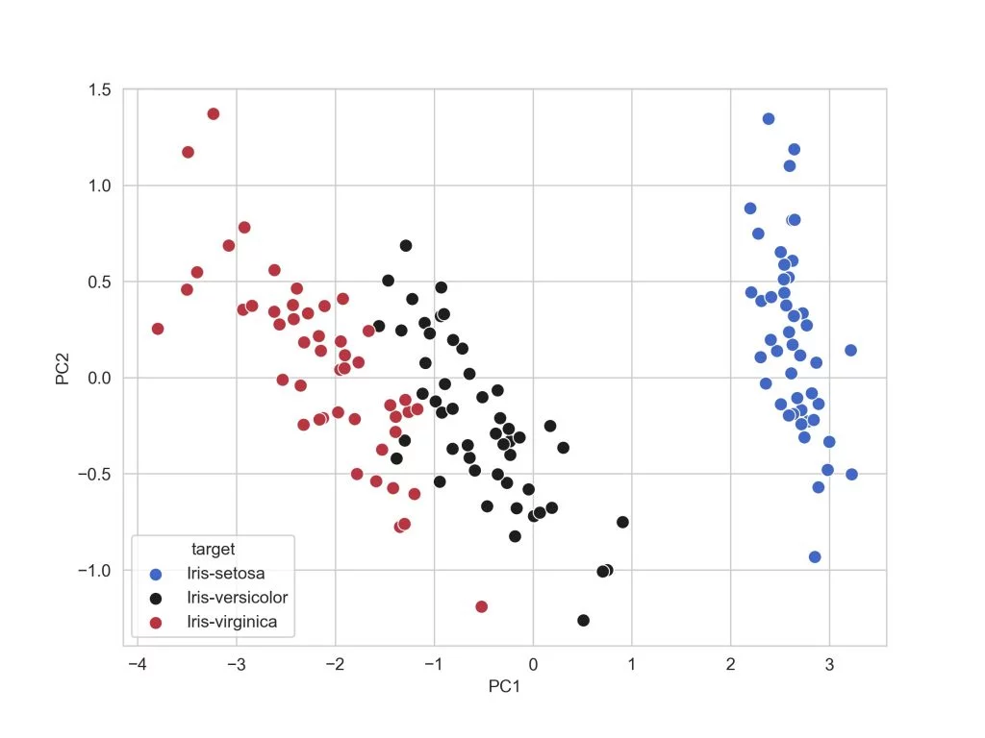

Reduced Dimension Plot Reduced Dimension Plot